KIDS Intensive Care & Decision Support and Neonatal Transfer Services
Guidelines for Melbourne Strapping of Oral Endotracheal Tubes
Equipment Required: Red Tape & clear label (cut into ‘trouser legs’), emergency airway equipment & suction.
Rationale: To ensure the safe & secure fixation of oral endotracheal tubes

Ensure the endotracheal tube is positioned to the corner of the mouth, pointing south.  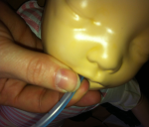 | Slowly peel the first tape from the clear label. Begin on the same side of the face where the tube is. Ensure the length of the tube is clearly visible Place the tape so the joining is at the corner of the lips on the cheek. Take the top ‘trouser leg’ and stick straight across face (between upper lip and underneath the nose)  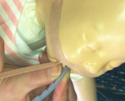 |  | Confirm the position of the tube before applying the bottom ‘trouser leg’.  Wrap the bottom trouser around the tube close to the lips, winding up the tube in a spiral fashion.  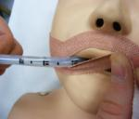  Ensure when strapping that lips and nares are kept visible and that you do not tape over them |  | Ensure the top of the tube is still visible after strapping (approximately 2cm). Once the tape is in place fold over a small piece in order to aid removal of the tapes for re-positioning.  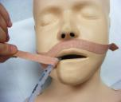
Take the second tape & begin from the other side of the face. Again, place the tape at the corner of the mouth, outside of the lips on the cheek. Take the bottom ‘trouser leg and tape directly across the face underneath the bottom lip.  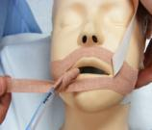 |  | Take the top ‘trouser Leg’ and place along the face (underneath the nose and above the top lip).  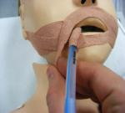 |  | 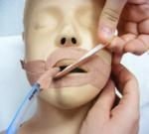  Once you have reached the corner of the mouth carefully proceed to wrap the tape around the tube moving up the tube as you go. Ensure you tape as close to the required length as possible. Again ensure you leave approximately 2cm of the top of the tube visible.
TW 01/12 KIDS version 1.0 review 2019

